- To access course documents on eReserve go to http://mptcres.wctc.edu/eres/default.aspx

- At that web site click on

- On the next screen click on the tab “Search for Course Reserves Pages.”
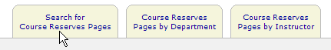

- In the empty window that next appears enter the first three digits of the course number followed by a dash and then the next three digits of the course number.
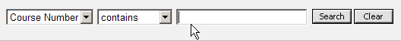

- After you have entered the appropriate information in the window (use the correct numbers for your course) then click on the search button.
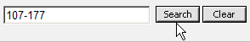

- Next, click on the link that appears for the course number.
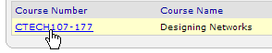
- The following message may appear

- Do as the instructions on the screen direct.
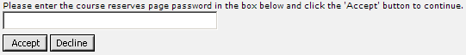

- The next screen to appear contains the documents and/or folders containing information and assessments that students may need while taking the course.
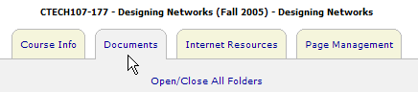

- There should be a folder that contains documents for course assessments. Documents might not be in the sequence you need to use them.
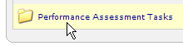

Note: Your instructor may refer you to some of the materials stored in eReserve while you are taking the course. For a variety of reasons the instructor may provide students with modifications to any of the documents in eReserve that you are directed to use. Also, you may be instructed to disregard some of the materials that are available in eReserve.

